Features
All aluminum structure, fanless design ;
Onboard Intel 10th Core i3/i5;
Support 1*DDR4 memory slot, Max.Support 32G;
Support 1*M.2 2280 slot, 1*2.5”HDD;
Support 2*COM (2*COM RS232/485 is Optional);
Support DC 12V Input;
Support OS：

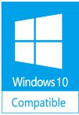
Nano N3022 Intel 10th generation core i3 / i5 processor Mini PC
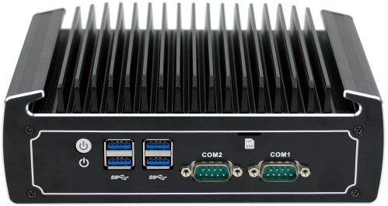
Specification
Model | Nano N3022
Color | Black (color can be customized)
Material | High-quality all aluminum
Processor | Intel Core i3 10110U (Dual core 4 threads, 2.1G, Max. Turbo 4.1G, 4MB Cache)
Processor | Intel Core i5 10210U (Quad core 8 threads, 1.6G,Max. Turbo 4.2G, 6MB Cache)
CPU Architecture | Comet Lake
RAM | Support 1*DDR4 2666/2933 SODIMM memory slot, Max. Support 32GB
BIOS | AMI EFI BIOS
Display Chip | Intel UHD Graphics for 10th Gen Intel Processors
Display Port | 1*DP, 1*HDMI
Front I/O | 2*COM (2*COM RS232/485 is Optional), 4*USB3.0, 1*Power Switch, 1*SIM slot
Rear I/O | 1*DC-IN 12V, 2*USB2.0, 1*HDMI, 1*DP, 2*Intel 1000M LAN,  1*Audio ( Support Mic and Speaker at the same time)
Expansion Slot | Support 1*M.2 2280 slot (Support M.2 PCIE X4 and M.2 SATA SSD);
Expansion Slot | Support 1*MINI PCIE slot (WIFI/3G/4G choose one from three),embedded SIM socket;
Network | 2*Intel i211-AT 10/100/1000M LAN
Storage | Support 1*M.2 2280 slot, 1*2.5”HDD, support RAID 0/1
Power Supply | DC 12V
Work Temp | 0℃ ～ +40℃(HDD), -20℃ ～ +50℃(Industrial grade SSD), surface air flow
Work Humidity | 5% ～ 95% non-condensing
Dimension | 186 * 126.5 * 66 mm
Net Weight | 1.3 kg
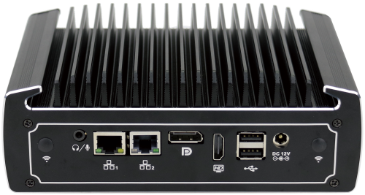
Accessories List
Name | Quantity | Specification
Power Adapter | 1 | i3 10110U suggest use 12V 5A
Power Adapter | 1 | i5 10210U suggest use 12V 5A
Power Cord | 1 | Any Plug is optional (Chinese, British, USA standard etc)
Order Information
Configuration one | N15 | Intel Core i3 10110U | Standard Port
Configuration two | N15 | Intel Core i5 10210U | Standard Port
N3022 Drawing

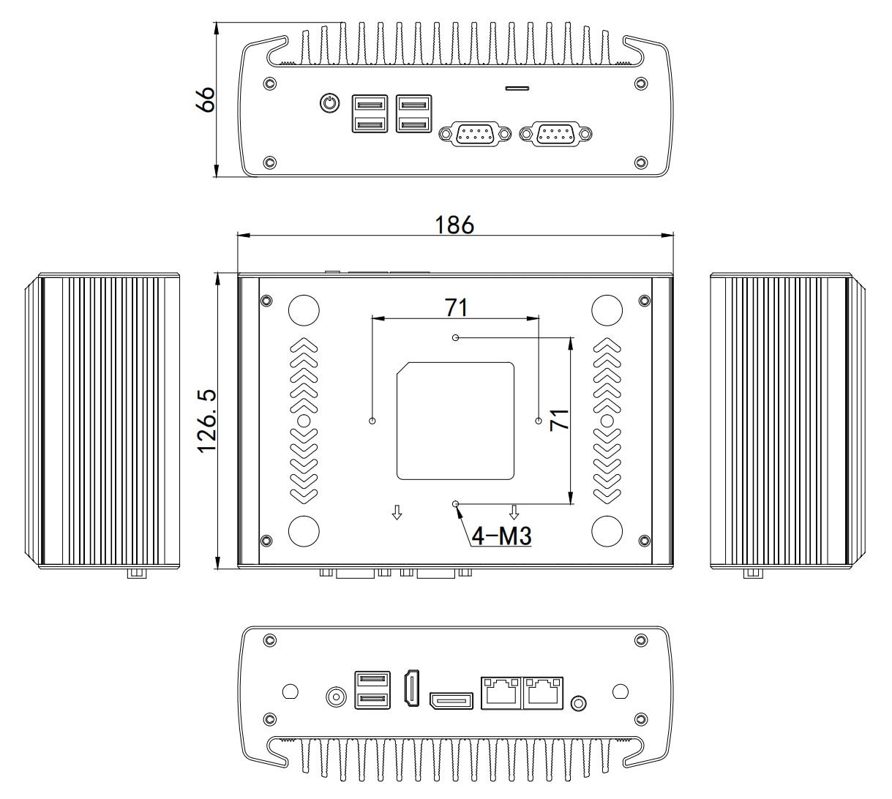

Application:
Business Office, HD Video Playback, Electronic Education, Industrial Automation etc.

